8DC00 Medische Beeldanalyse

# Project 1 - Registration

## Report

### 1-10-2021

Group 3

### Aiik Biermans – 1241616

### Brigitte van der Geest – 1464027

Pauline Haulez – 1462245  
Willem Schellikens - 1636308

# Introduction (1/2)

Image registration is really important in the medical field. There are several image techniques that are used for the evaluation and diagnosis of diseases and treatments in the hospital. Examples of medical image techniques are Magnetic Resonance Imaging (MRI), Computed Tomography (CT) and Positron Emission Tomography (PET), and they are used for different clinical applications because of their different image techniques and qualities. For these clinical applications it is necessary to compare different images of the different image techniques. Moreover, image comparison of different patients (for example control groups versus patient groups) and between the same patient (for example different time periods to evaluate the progress of a tumor) is important for clinical evaluation.

To compare different images, image registration is needed. Image registration is the process of aligning two images. A good and relevant comparison between images, require accurate alignment (Kostelec & Periaswamy, 2003). Point-based registration is based on the difference in the locations of some discernable feature points in the first and second image. The differences in locations of these corresponding points in the first and second image, are used to compute the translation to move the second image to get the same alignment as the first image. The target registration error (TRE) it the difference in some other target corresponding points, to evaluate the accuracy of the image registration. The disadvantage of point-based registration is the requirement of some user interaction to select the registration and evaluation points (Toennies, 2017).

Image intensity is an alternative registration method. Intensity-based image registration works by iterative optimization of an intensity-based similarity measure. To evaluate the accuracy of the intensity-based registration, a normalized cross correlation can be calculated. This evaluate the linear relationship between the pixel intensities in two images. If the alignment is accurate, the normalized cross correlation (NCC) will be close to 1. Another evaluation method is the mutual information (MI) between two images. It is a measure of how well you can predict the pixel intensity value in the second image, given the intensity value of the pixel in the first image. It measures the amount of information that one image contains about the other. The MI is maximal when the images are correctly aligned. An optimization is performed by calculating the gradient ascent, that results in an optimal transformation matrix (Toennies, 2017).

In this project, these two registration methods are evaluated: point-based registration and intensity-based registration.

SAMENVOEGEN MET:

Medical image analysis is an important diagnostic tool in daily clinics. Analyzing these images can be very difficult and have to be done by a professional. Although professionals are trained to analyze these images, differences between analysis of two professionals will stay. To make medical image analysis as objective as possible, an automatic analysis is required. An important part of automatic analysis is image registration, which is aligning two different images so they can be compared. This is for example important in keeping track of the size of a tumor over time. Two different ways to registrate images are intensity based registration and point based registration. Intensity based registration can be done by the use of normalized cross or mutual information. Intensity based registration is fully automatic while doing point based registration some points have to be picked in the original and in the moving image.   
The goal of this project is to compare and evaluate different inter-and intra-modal registration methods with the use of the following experiments: Image registration of two intra-modal images is performed with the use of rigid intensity based registration, affine intensity based registration once with the use of normalized cross correlation and once with the use of mutual information. Furthermore the registration of two inter-modal images is also performed with the use of affine intensity based registration, once with the use of normalized cross correlation and once with the use of mutual information. These inter- and intra-modal registrations will also be performed with the use of affine point based registration. From these the normalized cross correlation, the mutual information and the target registration error will be computed.

This way different methods of inter- and intra-modal registration will be compared and evaluated.

# Methods

A dataset with images of traverse slices of MR brain scans with two different sequences are used: T1-weighted and T2-FLAIR (Mendrik, et all., 2015). Every T1 slices comes in two versions: an original and a random transformed image with the addition of _d in the name.

From the dataset, the following images are evaluated:

- For intra-modal registration the image 1-1-t1 versus 1-1-t1_d and 3-3-t1 versus 3-3-t1_d are used. Intra-modal registration is the registration between images of the same patient of different patients using the same modality (T1-weighted).

- For inter-modal registration the image 1-1-t1 versus 1-1-t2 and 3-3-t1 versus 3-3-t2 are used. This is the registration between images of the same patient using different modalities (T1 and T2).

First of all, intra- and inter-modal registration is performed through point-based registration. Therefore, 4 points in the first image (named I) and second image (name I_m) are selected. These points are used to calculate the transformation matrix between these images. The I_m is then transformed (name I_t) using these matrix. The evaluation of these alignment is evaluated by selecting 4 other points in the original I and transformed I_t images. The average difference between these evaluation points is calculated, which is known as the target registration error (TRE).

Secondly, the intra and inter-modal registration is performed through intensity-based registration. The folowing registration methods and evaluations are performed:

- intra-modal rigid intensity-based registration, evaluated through the method of normalized cross-correlation.

- intra-modal affine intensity-based registration, evaluated through the method of normalized cross-correlation.

- inter-modal affine intensity-based registration, evaluated through the method of normalized cross-correlation.

- intra-modal affine intensity-based registration, evaluated through the method of mutual information

- inter-modal affine intensity-based registration, evaluated through the method of mutual information

After calculation the gradient ascent, the resulting optimal transformation matrix is applied and the above intensity-based registration methods are repeated.

The calculation of the TRE, normalized cross-correlation and mutual information are checked by performing the methods on two identical images: 1_1_t1 versus 1_1_t1 and 3_3_t1 versus 3_3_t1.

# Results (1/2)

Point based

|  |  |  |  |  |  |
| --- | --- | --- | --- | --- | --- |
|  |  | **Registration points [[ximage1][yimage1][ximage2][yimage2]]** | **Transformatie matrix** | **Target registration error points [[ximage1][yimage1][ximage2][yimage2]]** | **TRE** |
| **Intra-modal** | **1_1_t1 1_1_t1_d** | [[126.81612903 162.58387097 140.01612903 150.66129032]  [107.69074194 108.54235484 129.83267742 129.40687097]] [[126.11935484 162.31290323 139.74516129 150.39032258]  [107.26493548 109.81977419 128.98106452 130.68429032]] | [[ 0.99978948 0.00330636 0. ]  [-0.03645333 1.04128303 0. ]  [ 0. 0. 1. ]] |  | 22.802487333404255 |
| **Inter-modal** | **1_1_t1 1_1_t2** | [[126.81612903 162.15806452 138.31290323 151.08709677]  [105.98751613 108.11654839 130.68429032 130.25848387]] [[123.13870968 158.48064516 134.20967742 146.55806452]  [121.31654839 124.723 145.16170968 145.58751613]] | [[ 1.00130403 0.02841567 0. ]  [-0.09203554 0.98189642 0. ]  [ 0. 0. 1. ]] |  | 10.652963144485307 |
| **Intra-modal** | **3_3_t1 3_3_t1_d** | [[123.83548387 156.62258065 115.74516129 170.2483871 ]  [122.59396774 120.89074194 173.69074194 173.26493548]] [[126.11935484 158.90645161 121.43548387 174.66129032]  [140.47783871 136.64558065 194.98106452 194.55525806]] | [[ 1.0247544 -0.0437922 0. ]  [-0.01360917 0.89816566 0. ]  [ 0. 0. 1. ]] |  | 12.268786263127472 |
| **Inter-modal** | **3_3_t1 3_3_t2** | [[123.40967742 155.34516129 115.31935484 172.37741935]  [122.59396774 120.03912903 173.69074194 171.98751613]] [[123.99032258 154.6483871 112.91935484 168.27419355]  [139.20041935 136.64558065 185.61332258 187.74235484]] | [[ 0.98857632 0.02105937 0. ]  [-0.1094837 1.00190368 0. ]  [ 0. 0. 1. ]] |  | 8.757144536645509 |

Intensity-based registration

|  |  |  |  |  |  |  |  |  |
| --- | --- | --- | --- | --- | --- | --- | --- | --- |
|  |  |  |  | **Mu** | **Best initial parameter vector** | **Result CNN**  **With x_rigid = [0, 0, 0] and x_affine = [0, 1, 1, 0, 0, 0, 0]** | **Result CNN**  **With x = best initial parameter vector** |  |
| **Rigid** | **NCC** | **Intra-modal** | **1_1_t1 1_1_t1_d** | 0.0001 | [1.55e-06, 2.24e-06, -2.19e-06] | 1 | * | 5.096019642936107 |
| **Affine** | **NCC** | **Intra-modal** | **1_1_t1 1_1_t1_d** | 0.0001 | [0, 1, 1, -9.31e-08, -8.34e-08, 3.19e-07, 5.03e-09] | 1 | * | 18.211341839174064 |
| **Affine** | **NCC** | **Inter-modal** | **1_1_t1 1_1_t2** | 0.00001 | [0, 1, 1, 0.0024, -0.0025, 0.0019, -0.0019] | 0.53 | 0.54 | 213.01715887596708 |
| **Affine** | **MI** | **Intra-modal** | **1_1_t1 1_1_t1_d** | 0.00001 | [0, 1, 1, 2.32e-03, 8.89e-04, 1.16e-03, 1.22e-04] | 3.02 | 1.92  Raar dat deze juist lager is geworden | 2.200414900328276 |
| **Affine** | **MI** | **Inter-modal** | **1_1_t1 1_1_t2** | 0.001 | [0, 1, 1, 0.058, -0.050, -0.30, -0.078] | 0.72 | 0.85 | 157.94589400622704 |
|  |  |  |  |  |  |  |  |  |
| **Rigid** | **NCC** | **Intra-modal** | **3_3_t1 3_3_t1_d** | 0.0015 | [-0031, -0.088, -0.015] | 0.60 | 0.63 | 444.8768168938571 |
| **Affine** | **NCC** | **Intra-modal** | **3_3_t1 3_3_t1_d** | 0.0015 | [0, 1, 1, 0.0033, -0.081, -0.021, -0.094] | 0.60 | 0.74 | 193.38124376560867 |
| **Affine** | **NCC** | **Inter-modal** | **3_3_t1 3_3_t2** | 0.001 | [0, 1, 1, 0.047, -0.044, -0.053, -0.079] | 0.56 | 0.60 | 118.93945988935798 |
| **Affine** | **MI** | **Intra-modal** | **3_3_t1 3_3_t1_d** | 0.001 | [0, 1, 1, 0.0030, -0.080, -0.042, -0.10] | 0.63 | 0.83 | 122.35247015055984 |
| **Affine** | **MI** | **Inter-modal** | **3_3_t1 3_3_t2** | 0.001 | [0, 1, 1, 0.051, -0.061, -0.069, -0.066] | 0.71 | 0.82 | 97.2725132553789 |

* initial parameter vector is almost equal to the standard x_rigid = [0, 0, 0] or x_affine = [0, 1, 1, 0, 0, 0, 0].

# Discussion

The discussion section should contain the analysis of the results

# Appendix

# References

<http://library.msri.org/books/Book46/files/07kostelec.pdf>

<https://link.springer.com/content/pdf/10.1007%2F978-1-4471-7320-5.pdf>

[*A.M. Mendrik, K.L. Vincken, H.J. Kuijf, M. Breeuwer, W.H. Bouvy, J. de Bresser, A. Alansary, M. de Bruijne, A. Carass, A. El-Baz, A. Jogh, R. Katyal, A.R. Khan, F. van der Lijn, Q. Mahmood, R. Mukherjee, A. van Opbroek, S. Paneri, S. Pereira, M. Persson, M. Rajchl, D. Sarikayan, O. Smedby, C.A. Silva, H.A. Vrooman, S. Vyas, C. Wang, L. Zhaon, G.J. Biessels, M.A. Viergever. “MRBrainS Challenge: Online Evaluation Framework for Brain Image Segmentation in 3T MRI Scans.” Computational Intelligence and Neuroscience, special issue on Simulation and Validation in Brain Image Analysis 2015. Article ID 813696.*](http://www.hindawi.com/journals/cin/aa/813696/)

Voorbeeld registration points aanklikken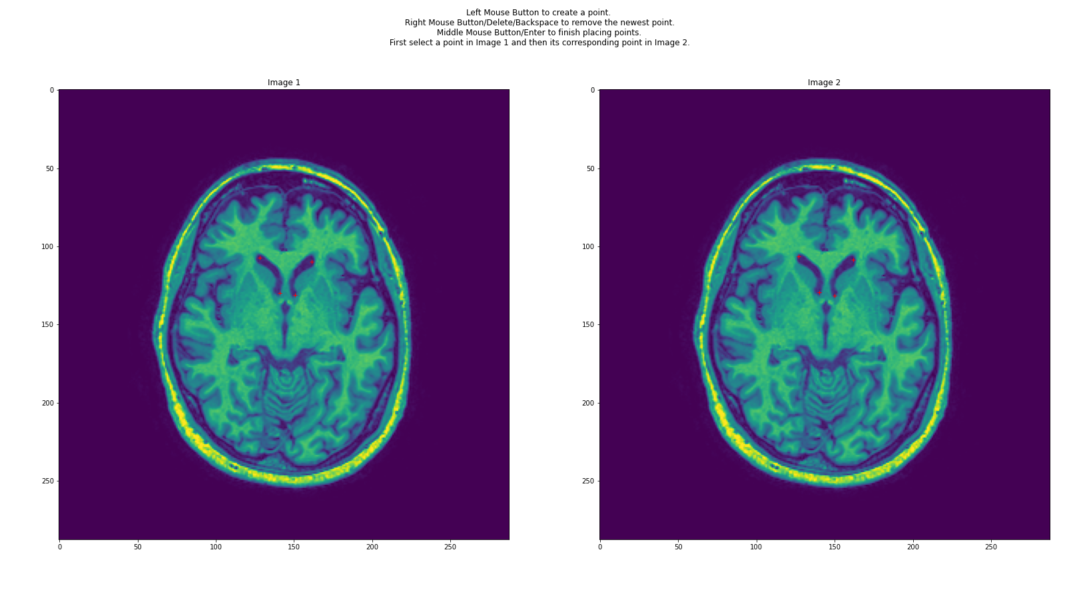

Point error

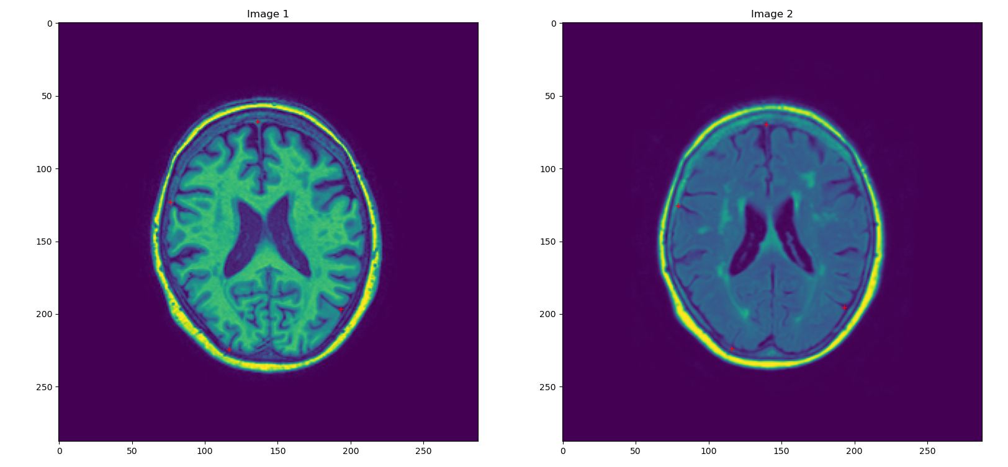

Ls_affine t1 en t1_d van patient 1

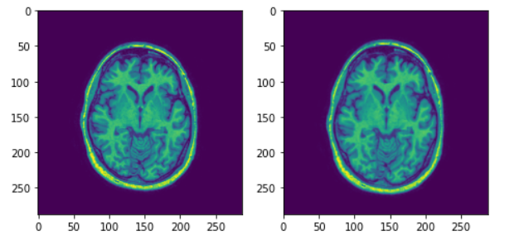

Ls_affine t1 en t2 van patient 1

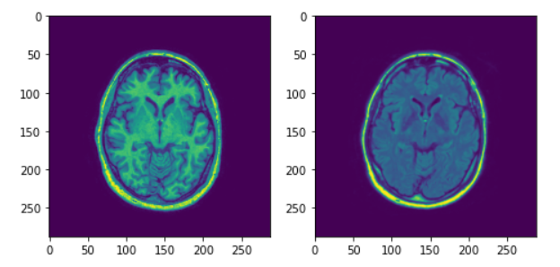

Ls_affine t1 en t1_d bij patient 3

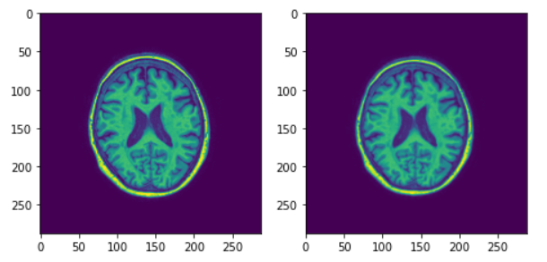

Ls_affine t1 en t2 bij patient 3

